Cloudflare Settings Optimization
- Additional Steps
  - Configure DMARC
    - The DMARC Aggregator Valimail (https://app.valimail.com/) is free for Office 365 Users
  - Configure DKIM records for each server which should be allowed to send mail on behalf of the domain
  - Configure SPF Record to include all servers which are allowed to send mail on behalf of the domain
  - Confirm the SSL Security Rating of the site at https://www.ssllabs.com/ssltest/
    - The Target is to achieve an A+ rating, which the settings below will achieve.
  - If you are using WordPress, Install the Cloudflare WordPress add-on on your website, and allow it to auto-optimize
  - Transfer your eligible domains to Cloudflare, they are significantly cheaper than providers like Namecheap and GoDaddy ($8 per year for .com domains)

- On DNS Page for each domain
  - Proxy only CNAME’s and A records which use HTTP or HTTPS. Other services will not work via proxied IP
  - Enable DNSSEC if available for your domain (be aware that some TLD’s and registrars do no support this yet)
  - Configure CAA Records for Cloudflare, as well as any other needed certificate providers, Cloudflare settings below:
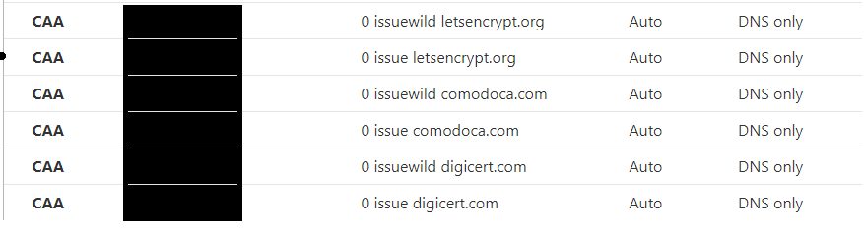
- On SSL/TLS Page for each domain
  - Overview Page
    - Set encryption mode to full
      - This can be set to Full (strict), but a valid SSL cert must be installed on each proxied web server
        - Alternatively, go to the Origin Server tab
        - Create a certificate and install it on the web server (be advised that this cert cannot be used without cloudflare’s proxy
        - Enable “Authenticated Origin Pulls”
    - Switch on SSL/TLS Recommender
  - On Edge Certificates Page
    - Switch on “Always use HTTPS”
    - Change HSTS Settings to below:
      - Enable HSTS
      - Max Age Header – 6 Month
      - Include Subdomains: On
      - Preload: On
      - No-Sniff Header: On
    - Minimum TLS Version: 1.2
      - Setting this to TLS 1.3 will give an “A” rating instead, but is actually more secure, some older browsers may not work with this.
    - Opportunistic Encryption: On
    - TLS1.3: On
    - Automatic HTTPS Rewrites: On
    - Certificate Transparency Monitoring: On
  - On Speed -> Optimizations Page
    - Enable all 3 options in “Auto-Minify”
    - Enable Brotli
    - Enable Rocket Loader
  - On Speed -> Browser Insights Page
    - Click Configurations and Enable Browser Insights
  - On Caching -> Configuration Page
    - Enable CSAM Scanning Tool using both lists
      - Registration and Logon details for the NCMEC are required
    - Enable Always Online
  - On Rules -> Settings Page
    - Enable Normalize incoming URLs
    - Enable Normalize URLs to Origin
  - On Scrape Shield Page
    - Enable Email Address Obfuscation
    - Enable Server-side Excludes
    - Enable Hotlink Protection

